PE – home learning
The school have purchased a new PE curriculum this year and they have very kindly created a home learning page so that the children can continue to build on core skills. Here are the details for how to access the activity. It is about a hour a day and can be done inside or outside with very little equipment. It would be great to get the children to do it a couple of times a week.
Go to web page: home.jasmineactive.com
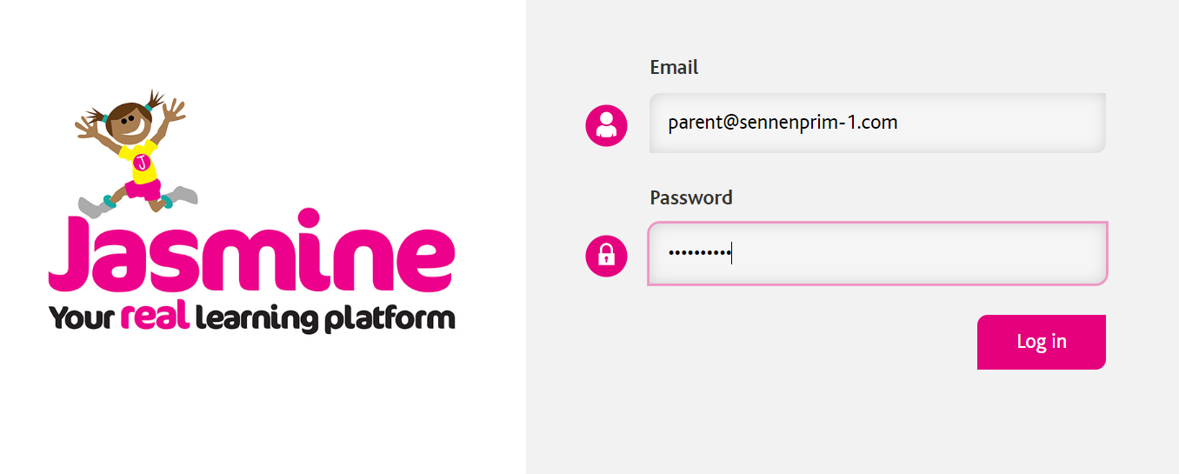
Enter email: parent@sennenprim-1.com
Password: sennenprim
There is an introductory video on the home page
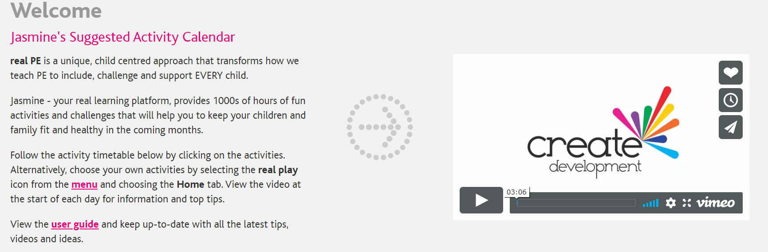
Scroll down to look at the sequence for the week:
Slide this tab along for years 3-6
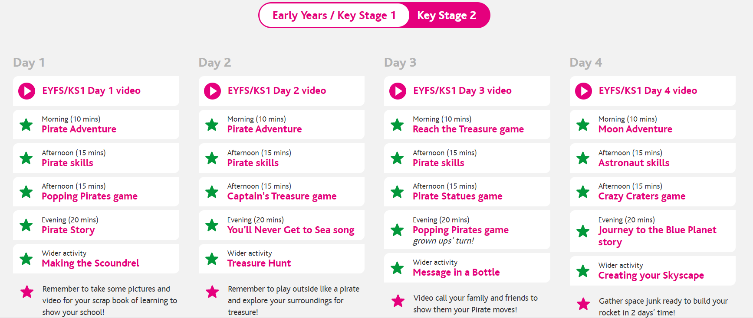
Watch the video first Then click on each star to get the instructions of the games.

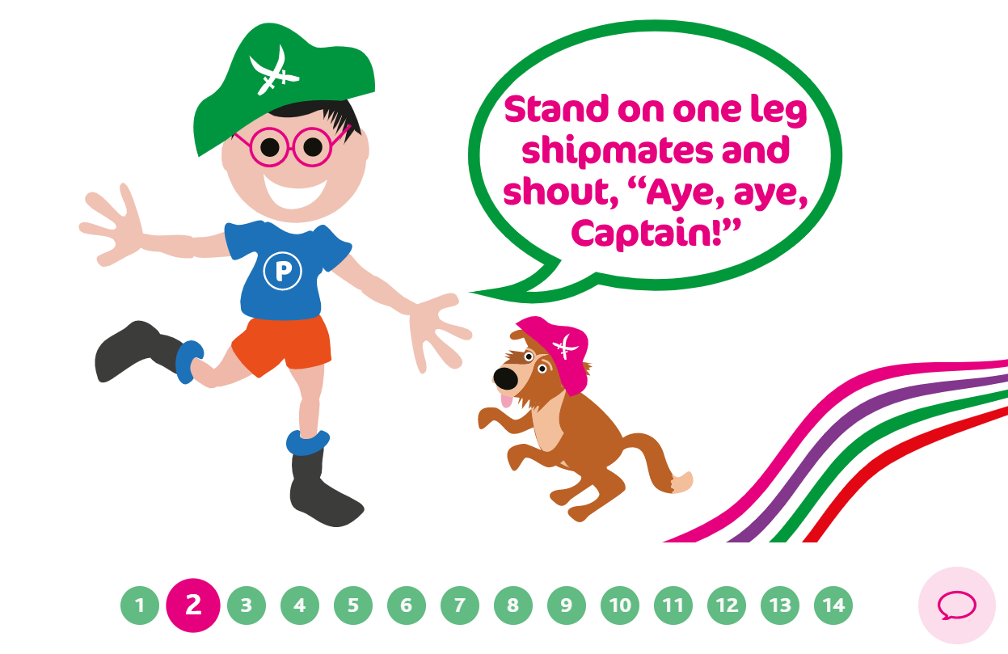
Click on each number to get the next stage of the activity. If there are no numbers it is just one activity to complete.

Get everybody involved – some of it is really tricky!

