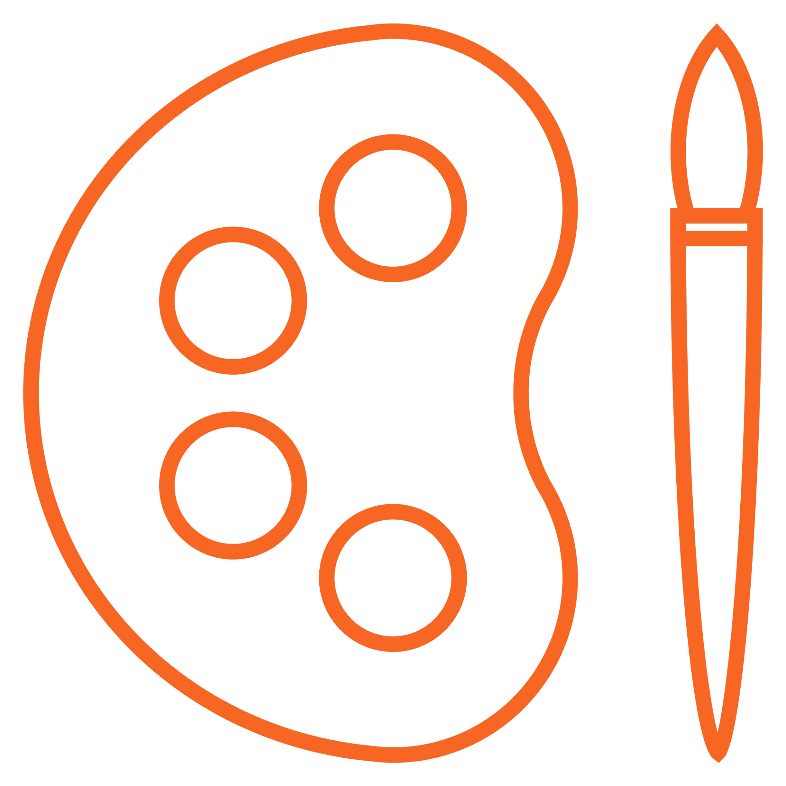

Art and design
Mixed-age plan

© Kapow Primary™
Access all these lessons with a free 7-day trial

Contents:

How does Kapow Primary help our school to meet statutory guidance for Art and design? | 3
How is the Art and design scheme of work organised? | 4
A spiral curriculum | 5
Discrete teaching of Art and design skills | 5
Is there any ﬂexibility in the Kapow Primary Art and design scheme? | 6
Other useful documentation | 7
Suggested long-term plan: Art and design (Mixed-age cycle) | 8

How does Kapow Primary help our school to meet statutory guidance for Art and design?

Our scheme of work fulﬁls the statutory requirements outlined in the National Curriculum (2014). The National Curriculum for Art and design aims to ensure that all pupils:

★ produce creative work, exploring their ideas and recording their experiences
Making skills
Generating ideas
From these aims, we have identiﬁed ﬁve strands which run throughout our scheme of work:

★ become proﬁcient in drawing, painting, sculpture and other art, craft and design techniques

★ evaluate and analyse creative works using the language of art, craft and design
Formal elements

Our Curriculum overview document shows which of Kapow Primary’s units cover each of the National Curriculum Attainment targets as well as each of these ﬁve strands. National Curriculum links are also on each individual lesson plan, along with cross-curricular links to other subjects.

★ know about great artists, craft makers and designers, and understand the historical and cultural development of their art forms
Knowledge of Artists
Evaluating

How is the Art and design scheme of work organised?

Making skills

Generating ideas

Formal elements

Knowledge of artists

Evaluating

Kapow Primary scheme of work

Units which teach skills discreetly: Units which give an opportunity to apply skills:

Years 1-5
Formal elements of Art

Art and design skills

+1 other unit

+1 other unit

Year 6 only

+1 other unit

+1 other unit

Art and design skills

+1 other unit

A spiral curriculum
Kapow Primary’s Art and design scheme has been designed as a spiral curriculum with the following key principles in mind:

- Cyclical: Pupils return to the same skills again and again during their time in primary school.

- Increasing depth: Each time a skill is revisited it is covered with greater complexity.

- Prior knowledge: Upon returning to a skill, prior knowledge is utilised so pupils can build upon previous foundations, rather than starting again.

Discrete teaching of Art and design skills

Formal elements of art units
With the exception of Year 6, each year group has a unit called ‘Formal elements of Art’ which focuses on the discrete skills of the formal elements of art which are:

- Line
- Shape
- Tone
- Texture
- Pattern
- Colour
Art and design skills units
Each year group has a unit called ‘Art and design skills’ which focuses speciﬁcally on developing pupils art, craft and design skills in a discrete way.

Application of skills
The knowledge and skills from these two recurring units are then applied throughout the rest of the scheme within the other units (eg. Sculpture and collage, Prehistoric art etc. ) See Next Slide for more information about how to arrange our units to suit your schoo
Suggested long-term plan: Art and design (Mixed-age)
 | Cycle A |  |  |  | Cycle B
Year 1/2 | Year 3/4 | Year 5/6 |  | Year 1/2 | Year 3/4 | Year 5/6
Formal elements of art Shape, line and colour | Formal elements of art Shape and tone - observation | Formal elements of art Architecture |  | Formal elements of art Pattern, texture and tone | Formal elements of art Texture and pattern | Make my voice heard
(5 lessons) | (5 lessons) | (5 lessons) | Unit 1 | (5 lessons) | (5 lessons) | (5 lessons)
Art and design skills  (6 lessons)  Landscapes using different media  (5 lessons)  Sculptures and collages  (5 lessons) | Art and design skills  (7 lessons)  Prehistoric art  (5 lessons)  Craft  Materials - tie-dye, weave, sew  (5 lessons) | Art and design skills  (7 lessons)  Every picture tells a story  Analysing famous artists’ work  (5 lessons)  Design for a purpose  (5 lessons) | Unit 2  Unit 3  Unit 4 | Art and design skills  (7 lessons)  Human form  (5 lessons)  Sculpture and mixed media  (5 lessons) | Art and design skills  (7 lessons)  Every picture tells a story  Analysing famous artists’ work  (5 lessons)  Sculpture Recycled materials  (5 lessons) | Art and design skills  (6 lessons)  Photography  (5 lessons)  Still life  (5 lessons)

