Daily Reading
Reading books can be found online using the website below:
https://www.oxfordowl.co.uk/

- Click on My Class Login
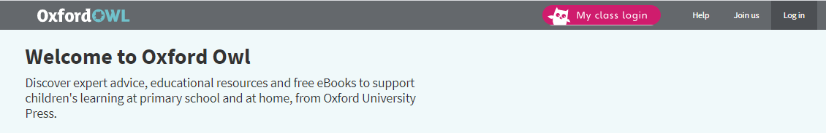
- Enter the class login details.
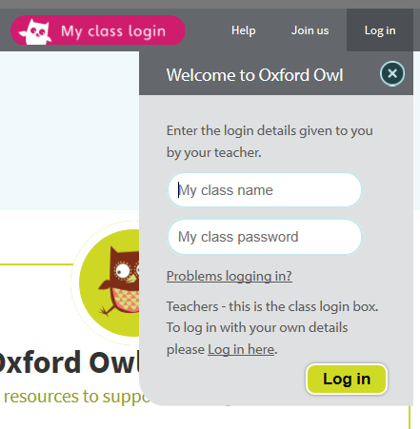

brisons1 or Longships1
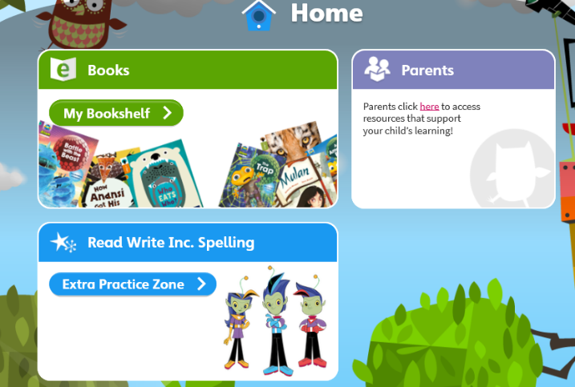
read
3. Select My Bookshelf

4. Find books according to age groups, series or themes. The age group tab is probably the best place to start.
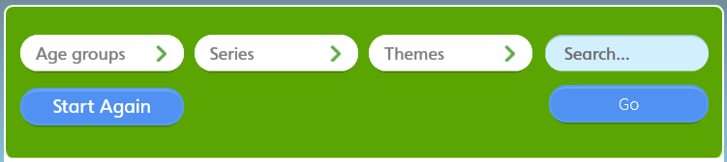

5. Click on a book to select it. It will open up in a separate tab at the top of the screen. Click on this to read the book.
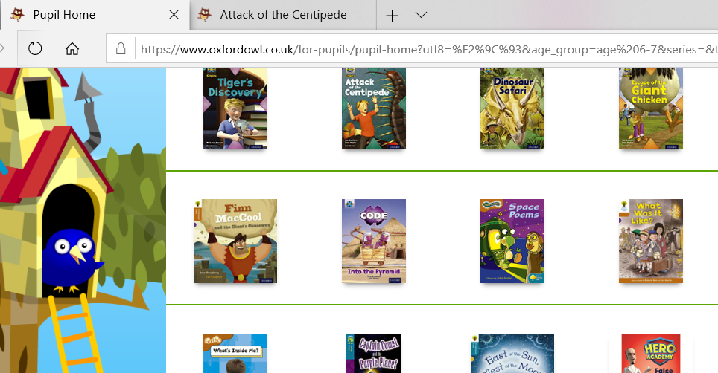

6. Read the book. Turn pages by clicking on the arrows below.
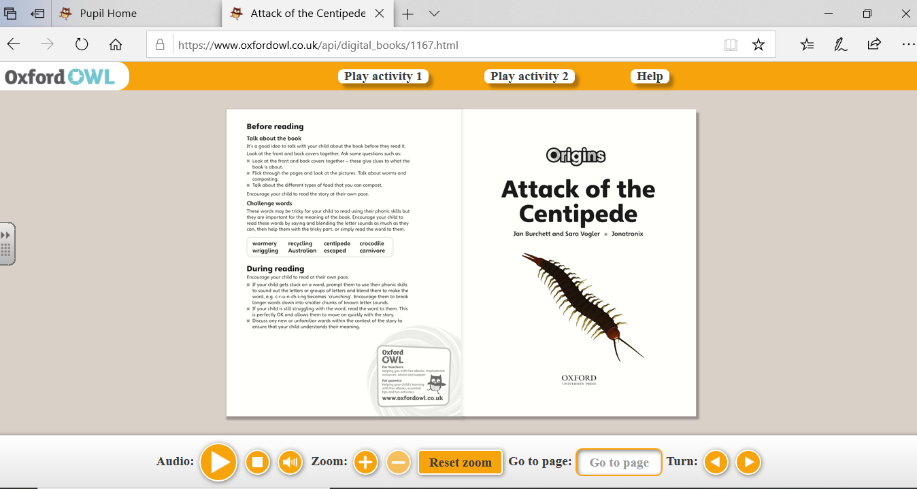

The audio button will also read the text aloud which is helpful to show fluent reading, expression and words that are difficult to read.
Some books will also have activity tabs which can also be completed.
The inside cover of each book will give suggestions on how to support with reading. These can be used alongside our reading VIPERS which will help with questions and book talk.

