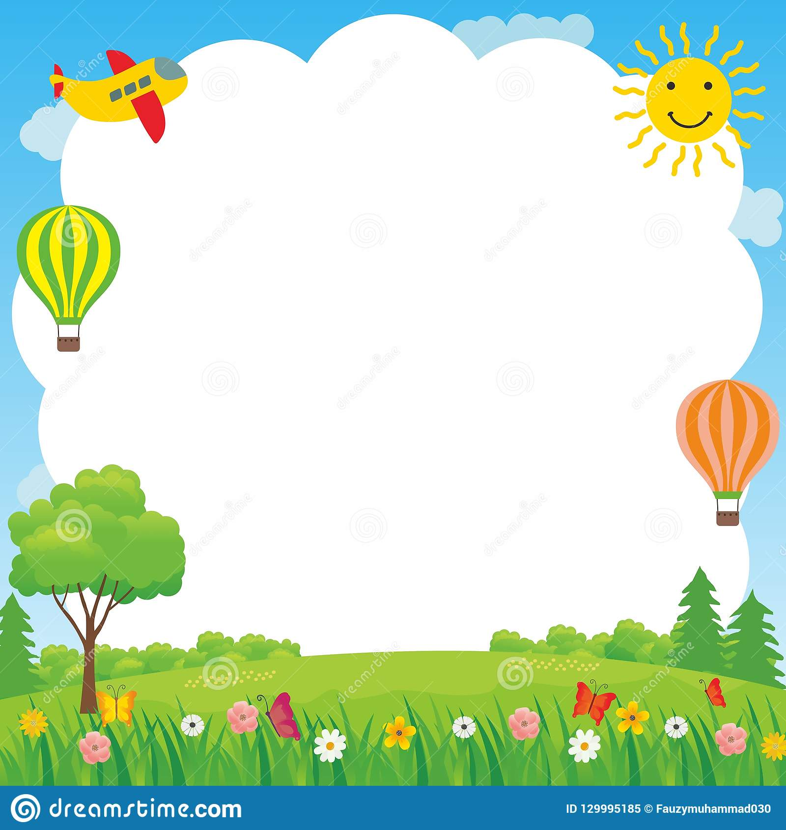

The Hot Air Balloon
This is a relaxing visualisation exercise that helps to release feelings. Make sure everyone is sitting comfortable before you begin to slowly read this aloud. You may want to record yourself reading this out so that you can take part too.
Start to relax by taking some, easy breaths…and now begin to picture a brightly coloured hot air balloon, hovering ready to lift its basket off the ground and up into the sky.
When the balloon and the basket are clear in your mind, take your troublesome feelings and put them in the basket. Let them take up as much space as they need – there’s plenty of room.
Now picture the ballon slowly lifting the basket off the ground…gradually it rises up and up until it is outlined against the clear blue sky…keep watching as it rises into the air, getting higher and higher, until it begins to seem smaller as the breeze blows it gently away from you, carrying away the troublesome feelings.
Where those old feelings were inside you, imagine a new sense of lightness, or space, or peace…and as the watch the balloon drift away until it is only a speck in the distance and becomes part of the blue sky, let yourself be filled with this lightness, space, peace…
Then, when you are ready, and remembering that you can return to this new peace whenever you want to, come slowly back to where you are here, and now.

