Sennen School Marking Policy

Aims
The aims of this policy are:
- To ensure a consistent approach to the marking of children’s work, throughout the school.
- To facilitate the use of assessment for learning through marking, by allowing children to recognise where they have been successful, and what they need to do next to improve their skills, knowledge and understanding of concepts.

The Principles, Policy and Practice of Marking
The primary purpose of children’s written work is to allow pupils to demonstrate the extent of their understanding of the learning objective and as such is a crucial part of the assessment for learning process. Further it enables the teacher, through marking, to give feedback to the pupil: praising their effort and success and helping the child to identify what they need to do in order to improve their work.
However, whilst marking is an important tool in assessment for learning it can also be very time-consuming and therefore it is essential that a method is adopted that is both efficient for the teacher and effective in allowing the child to recognise the next steps to be undertaken.
Literacy and Numeracy are the subjects that will be most rigorously marked by use of marking codes, highlighting, next steps and brief comments (e.g. well done) as outlined below.

Sennen Marking ‘at a glance’
- Quality feedback and developmental marking is used.
- Marking focuses on the main learning objective and success criteria, the pupil’s current target(s) and other knowledge that has been taught. Teachers do not correct errors that have not yet been taught, so as not to discourage pupils from making ambitious choices (e.g. a child may attempt to use speech marks in year1).
- Marking codes are used for efficiency. The marking codes used, reflect the programme of study and are only introduced once taught.
- Highlighters may also be used: green for great (praise) and pink for think (next step).
- Regular ‘response to marking’ time is given to children (purple polish work)
- Teachers mark in green and TAs in black so it is clear who has marked. Marking should be completed be legible and neat; acting as a positive role model to the child.
- Pupils respond to all formative marking with purple pen.

Marking in Literacy and Maths
Many of the marking codes apply more to writing than Maths; however, the principles of marking are the same in both subjects:
- Success Criteria or WALTs should be stuck in at the beginning of most pieces of written work and Maths. In maths this may include a self assessment before the lesson and then again after the lesson to gauge pupil confidence
- Children should check and assess their own work against the success criteria in most lessons.
- Work should be marked by the adult who worked with the child in that lesson (teacher or teaching assistant).
- Adults also mark against the success criteria and may highlight evidence of where this is met in the work (green). Highlighting may also be used to recognise where the child has achieved outside of the success criteria with a brief comment making this clear.
- Errors/areas for improvement can also be highlighted, in pink. The relevant marking code is used alongside the highlighting to explain to the child what type of error has been made.
- Marking codes are written on to the work for younger pupils so they can see exactly where the error is. As pupils gain confidence, the marking codes are put into the margin rather than on the work, to encourage the pupils to be independent and take more responsibility for editing and improving their work.
- Highlighting should be used sparingly as it should not overwhelm the child when they check their work and should only relate to those aspects of the work that it is reasonable to expect the child to complete correctly.
- All written feedback should include a positive comment and next step focusing on the following: improvements made by the child compared to previous work / on-going targets / learning objective / success criteria / the child’s own assessment.
- Verbal feedback given during, or after, a lesson can be regarded as a developmental remark and a note should be made on work to this effect by writing V.F. on the work.
- Support given to the child during the lesson should be recorded where appropriate on the work by the use of the following initials: T (teacher support), TA (teaching assistant support) or PS (peer support). Further annotations may be used where necessary, such as I to indicate where independent work has begun.
- Peer Assessment is a useful tool in the Assessment for Learning process and should be done regularly, especially with older pupils.
- Children should be given regular time (e.g. at the start of each lesson or during ‘early morning work’) to respond to marking using a purple pen. This should happen at least twice a week.
Marking of spelling:
Pupils’ work is sensitively marked to enable all aspects of their creative writing to be assessed; particularly the use of interesting vocabulary that they may not necessarily have spelt correctly but have attempted. Wherever possible, spelling errors are tackled with pupils present. Teachers highlight misspelt words in Key Stage 1 as appropriate and up to three misspelt words (High Frequency) in Key Stage 2 using the initials ‘sp’ in the margin. To support self-correction Years 3 and Year 4 pupils’ misspelt words can be highlighted with a line underneath; misspelt words in Year 5 and Year 6 are identified using ‘sp’ in the margin or at the bottom of the page. Pupils are given time to correct any spelling errors.

In Numeracy:
- Work should be marked with a tick if correct and an arrow if the child needs to try again.
- At least twice a week each child should have a developmental task included in their feedback. This can be through the use of ‘Mathematics Mastery’ extensions, asking the children to expand or deepen the learning of a question they have already written or a new challenge. Some examples are below:
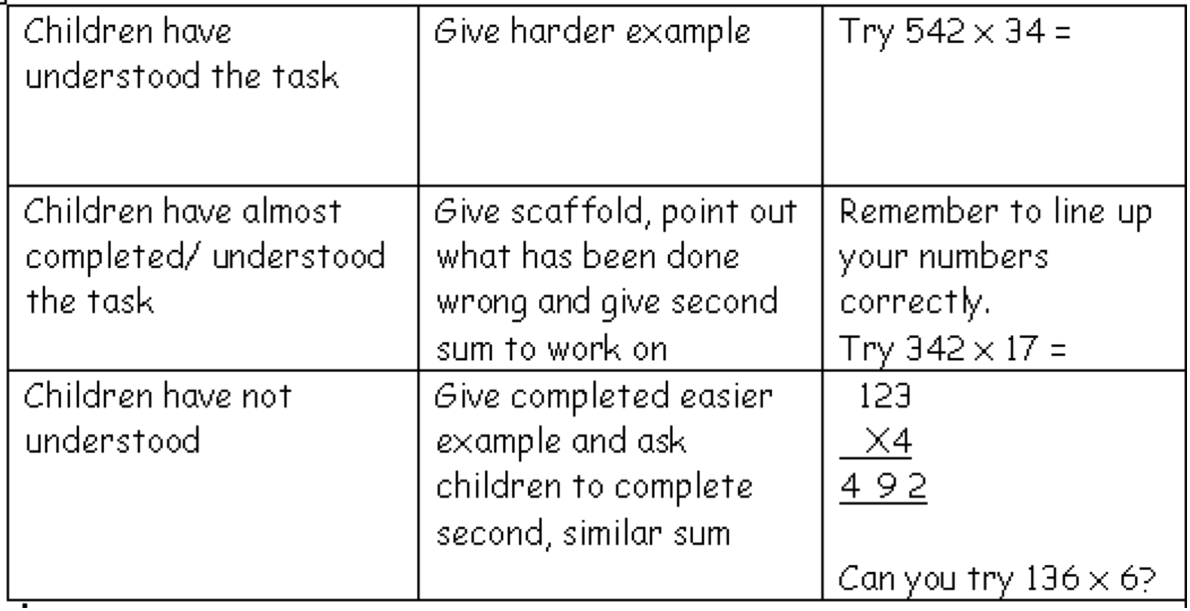

Where a child has not understood the lesson, a same day intervention needs to be delivered as a form of tutorial and marked with the adult’s initials.

Other Curriculum Areas
Whilst Science being a Core Subject should be developmentally marked regularly, in all other subjects such detailed marking is not required, although basic spelling and punctuation errors should be highlighted. Children should still feel that their efforts in these lessons is valued, so a brief comment should be added at the end (e.g. well done, good understanding, you have worked hard).

Policy Review
This policy will be reviewed annually during Term 5.
The next review of this policy is due: Summer Term 5, 2020.

References
The Marking Policy forms part of the Whole-school policy on Assessment.

Appendices:
Appendix A: Marking codes

Appendix B: Guidance on formative marking in Literacy – ‘level 1’ and ‘level 2’ marking

Appendix C: Ways to hold pupils to account and make marking worthwhile

Appendix D: Other examples of formative response marking: DINT (Do It Now Task)

Appendix E: Examples of using Mathematics Mastery stickers

Appendix A - Marking Codes
In EYFS and Key Stage 1, marking codes should be used sparingly, reflecting what has been taught. E.g. if capital letters have not yet been taught, it is not appropriate to mark to show they are missing. The teacher or TA may mark directly onto the work, or above the words. During very young pupils’ emergent writing, it is important to encourage and praise their efforts. Teachers may tick every correct sound in a word when pupils are first learning to encode phonetically.

In Key Stage 2 (and Year 2 if pupils are ready), marking codes will usually be used in the margin, to promote pupils’ independence and encourage them to take responsibility for editing their work. E.g. if they have omitted a question mark, the teacher will use the correct marking code in the margin on the same line; the pupil will need to look along that line to find the error and correct it with green pen.

EYFS and KS1 Marking codes (to be introduced one at a time as knowledge is taught):
Teacher Support | 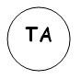  TA Support | 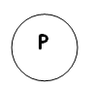  Paired Work
Got it! | 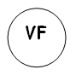  Verbal Feedback given | Independent Work
aBc Capital letter in wrong place | Neat Handwriting | FS Finger spaces
write on lines | read your work | 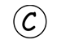  Capital letters
Spelling error | This section doesn’t make sense | Sound out your words
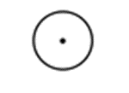Full Stop Missing

Full Marking codes (for use in KS2):
Teacher Support | TA Support | Paired Work
Got it! | Verbal Feedback given | Independent Work
aBc Capital letter in wrong place | Neat Handwriting | FS Finger spaces
write on lines | read your work | Capital letters
Missing Punctuation  (A circle with the missing punctuation symbol inside)  ! ? “ . , … ‘ ( ) | Give 3 synonyms  (Select the unambitious word from the pupils’ writing) | PR Presentation needs to improve
Spelling error | This section doesn’t make sense | -Next step  -Extend this sentence
New paragraph | ^ Word missing | Sound out your words

Appendix B – Formative marking in Literacy

Level 1 marking: Describing

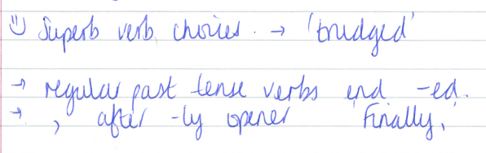
e.g.

Level 2 marking: Closing the gap

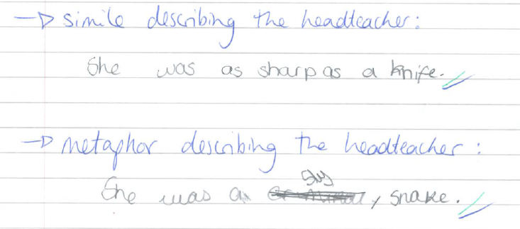
e.g.

Appendix C – Ways to hold pupils to account and make marking worthwhile

Find evidence

- Circle your most powerful adverb
- Underline all your adjectives
- Circle your capital letters
Edit/improve own work

- Add in the missing punctuation
- Replace the green words with better vocabulary choices
- Add in the missing words
- Finish your final sentence
- Re-write paragraph 3 in neat, joined handwriting
- Rewrite this sentence, using a subordinate clause.
- Show me you can using commas in a list/write a rhetorical question.
Extend:

- Why?
- Explain why you have used this word.
- Write the rule for using apostrophes for contractions.
- You have used __ - what other words could you have used?
- What other words use an apostrophe for contraction?
- Why did that you need a © at the start of a place name.
- Write a definition of a noun/verb/adverb/adjective.
- Use a thesaurus to collect some good vocabulary for tomorrow’s setting description.
- Justifying author’s intent
- What is the purpose of _________ device (stylistic choice)

Appendix D - Other examples of formative response marking:

DINT (Do It Now Task)

Cloze procedure/multiple choice:

The boy went/goed to the shop.  They eated/ate the cake.  She speaked/spoke to the witch | go The boy _____________ to the shop.  eat The boy _____________ the cake.  speak The boy _____________ to the witch.
To/two/too  I want to come _____.  I have ______ balloons.  We went ____ to beach. | What is the best word to describe his face?  Wizened/wrinkled/youthful  Add it in to your description.
Circle the verbs with a regular past tense ‘ed’ ending.  speak run sing beg cry argue | Which is correctly punctuated?  “Stop”!  “Stop!  “Stop!”

List:

Write 3 powerful verbs to tell me how the monster moved, e.g. stomped  1  2  3 | When do we use capital letters?  1  2  3
Write 3 synonyms for ran:  1  2  3 | Can you think of 3 metaphors for the storm?  1  2  3

Match:

Match these speech tags and adverbs  Screamed angrily  Exclaimed annoyingly  Whined deafeningly | They  He go  I goes  We
Adjective slowly
Adverb delicious
Noun ate
Verb sandwich
Now write a sentence with these words.
Change:

Write these verbs in the past tense  speak run sing beg cry argue | Write this sentence in the first person:  He walked into the classroom and put his coat on his peg.
Can you reorder this sentence?  Miss Casassa hungrily ate her lunch. | Add a relative clause to this sentence:  Mr Molver stood at the front of the hall.

Demonstrate comprehension of alternative spellings by showing both in context:

our/are | there/their/they’re
Write a sentence with both/all three

