PE
Intent
At Sennen School we believe that children don’t need to be experts in different sports, they need to be educated in the importance of being physically active. The curriculum and the school’s wider work support pupils to develop resilience, confidence and independence and lead a healthy and active lifestyle, helping them to know how to keep physically and mentally healthy. We use an approach and supporting resources that would directly align with the vision and values of our school. We know active, healthy children achieve more. It was essential that Physical Education supported the philosophy of our School, developed the whole child and that every pupil felt included, challenged and supported. Our real PE programme enables all teachers and support staff to deliver exciting and engaging lessons with the confidence over time to deliver outstanding outcomes for all children.
Implementation
We use the Real PE programme to deliver our physical education sessions. Real PE is a PE curriculum philosophy and approach which helps ALL children develop the physical literacy, emotional and thinking skills to achieve in PE, sport and life. It places the learner at the heart of practice with the ultimate goal of transforming how we teach PE, applying all of the high-quality learning and teaching skills that have become the norm in other subjects. Each lesson aims to develop children’s personal, social, cognitive, creative, physical, health and fitness skills.
EYFS – Fundamental movement skills
KS1 – Fundamental movement skills + Core skills
KS2 – Core skills
Impact
Children’s progress against key physical skills will be measured using the create development wheel. The expectations are set out as below.
Outcome
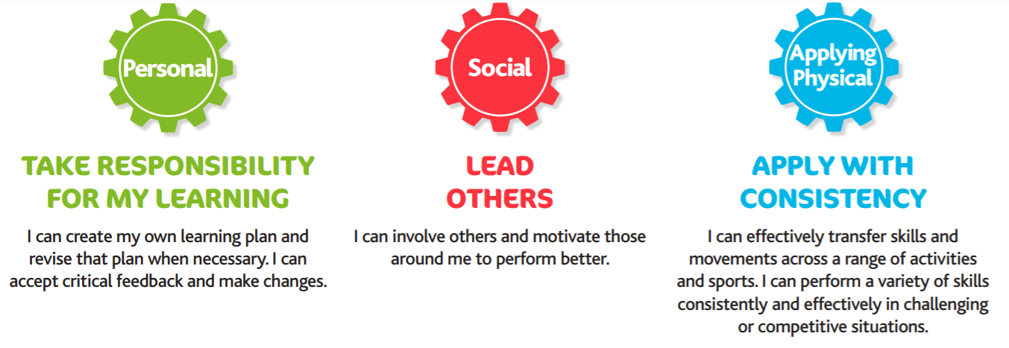
Beyond KS2
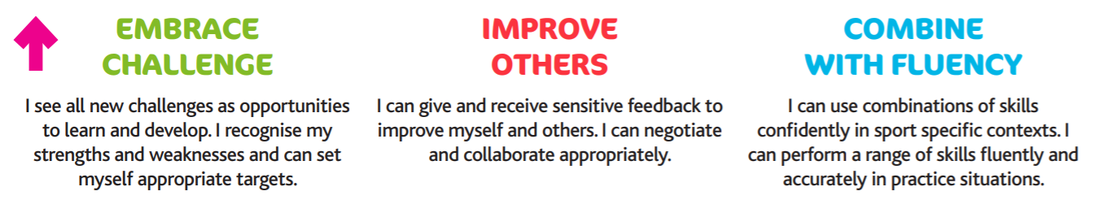
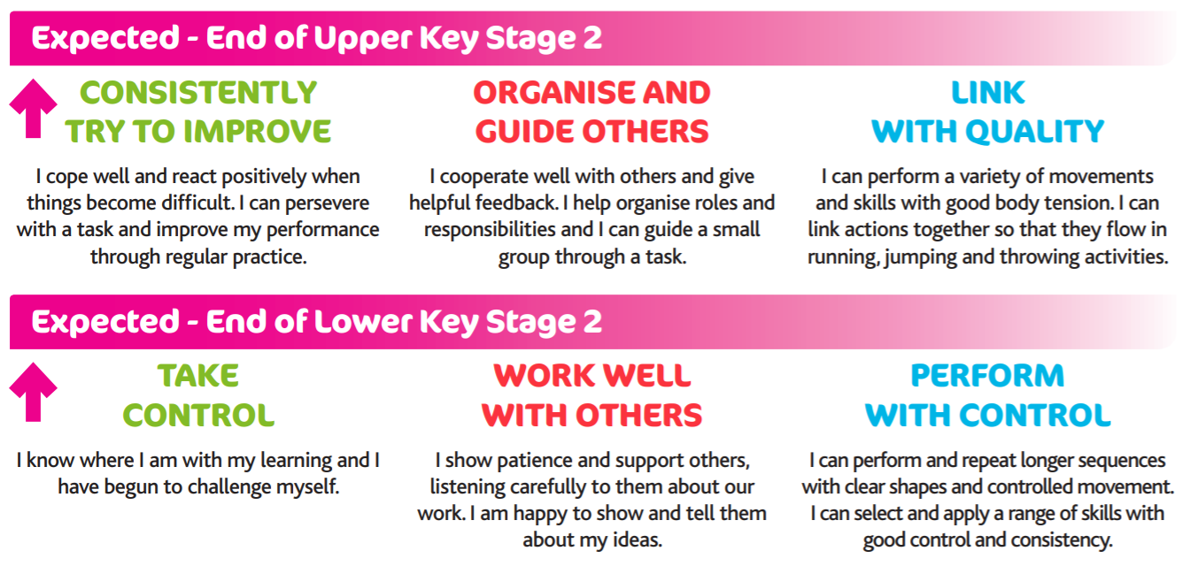
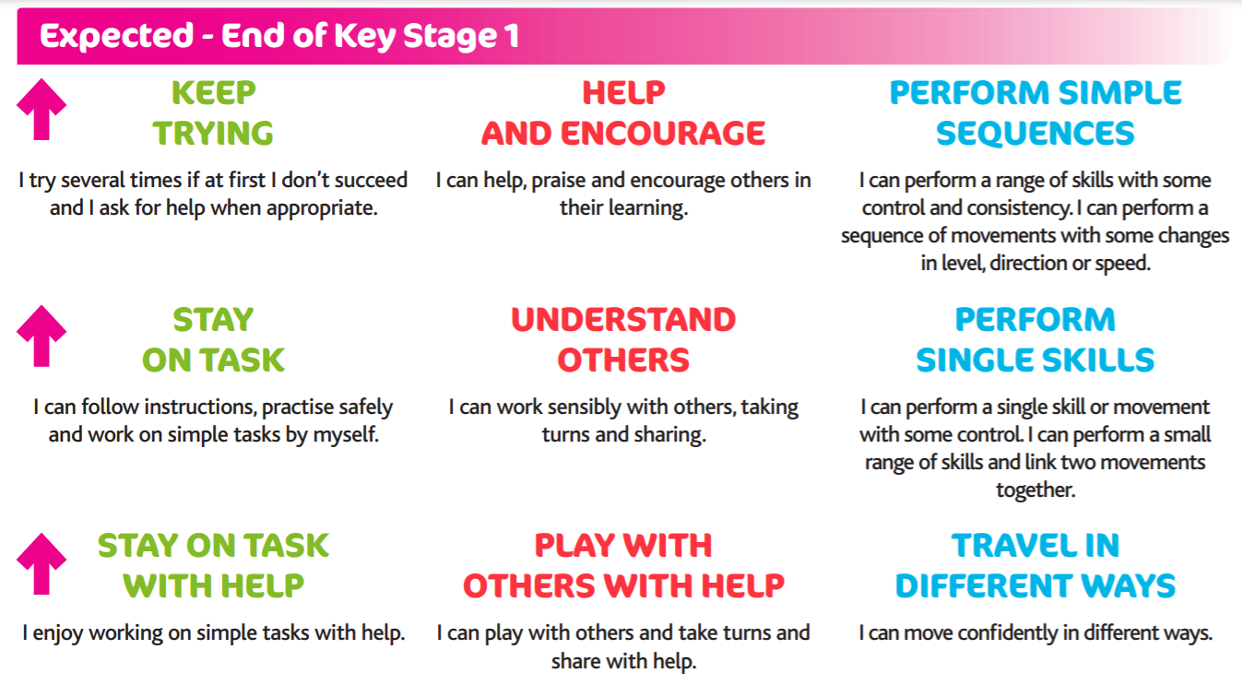
Outcomes
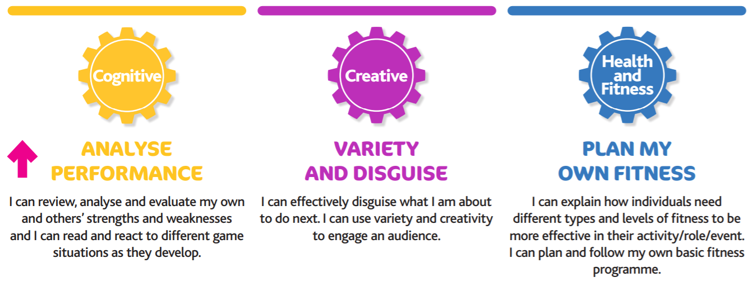
Beyond KS2
