10.6.20

Dear parents,

It has been so lovely seeing some of our children in school this week, I didn’t realise just how much I had missed seeing their smiling faces! The older children have been very reflective on their home learning and we have identified areas to work on. The younger children have been busy with Mrs Garbutt and planning their learning for the term. They have loved catching up with each other but they have all been so sensible, it has been a real pleasure to have them in.

Yesterday there was an announcement from Gavin Williamson, the Education Secretary, which stated that plans for wider opening of schools have been dropped. Early indications suggest that it will be down to individual schools to decide whether they can safely accommodate more children. We are continuing to follow the guidance set and will be thinking about what extra provision we could offer our pupils over the next week. The safety of children and staff will always remain a top priority but we also want to make sure that we are able to support the families that need us; the school building is not the same without the buzz of children and the staff are missing them all terribly. In order to plan effectively, it would be useful to gauge how many families would want us to provide some provision for their children in the lead up to the summer holidays. I can’t say whether this would be full time or part time at the moment as it would depend entirely on numbers.

We will be working hard over the term to try and keep our school community together as much as possible, finding ways to connect the learning happening at home to the learning at school. We will still provide home learning for those who choose not to come in. I am hoping to get a joint project or 2 up and running so that we can continue to make everyone feel valued. Year 6 this week decided to walk around the village to wave at some of their friends, it was so lovely to see.

I have a meeting with the Trust on Friday where we will be discussing scenarios so I would like to make sure that I have some idea what people are thinking. We are asking families to respond to this email either saying:

I would like my child / children to have some educational provision for the rest of this term (please state number of children in the family)

Or

I would not like to send my child / children back for the rest of this term.

If you would like to see how our school are managing the environment, there is a video on Facebook which I will put onto our website by the end of the day.

If you have any further questions, please ask.
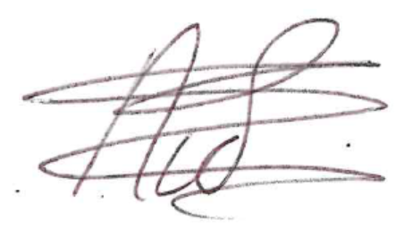

Nichola Smith

