Maths for SEND learners at Sennen
Teachers must construct a curriculum that is ambitious and designed to give all learners, particularly the most disadvantaged and those with SEND or high needs, the knowledge and cultural capital they need to succeed in life.
With this in mind, at Sennen school we make it our priority to ensure all of our children’s needs are met in Maths. Every teacher knows their individual pupils, their needs, what is ambitious for each individual and what measures are in place to meet their goals.
In order to achieve this, teachers use a range of strategies:
- Use of concrete and pictorial representations
- Revisiting and reminding
- Misconception planning
- Pre-teach
- Interventions
- Low floor, high ceiling tasks

Use of concrete and pictorial representations
We use a wide range of manipulatives to help children understand key concepts. These include place value counters, numicon, dienes and bead strings. The children then move on to drawing these representations in a variety of ways.
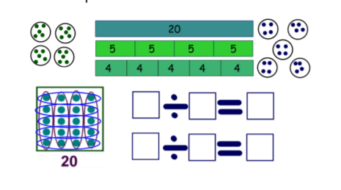
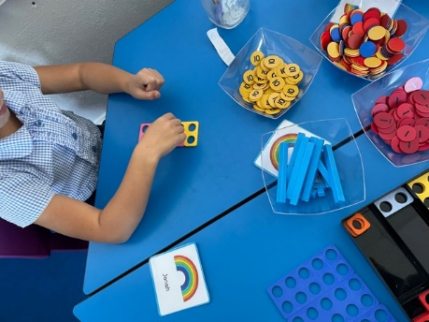

Revisiting and Reminding
Daily fluency sessions in Years 5 and 6 in fluency fitness books – regularly revisit and check learning from previous topics
Daily fluency sessions in Years 3 and 4 (focus on multiplication due to Year 4 Multiplication check)
Daily fluency sessions in Years 1 and 2
(These include flashback 4, mastery questions from NCETM, quick fire questions)
Misconception Planning
When planning a unit, teachers research and check common misconceptions and include these in their lessons where necessary.

Pre-teach
This is a great technique teachers use to support SEND children as it gives them a ‘head start’ and increases confidence.
Interventions
Teachers know their children really well so use a variety of targeted interventions and same day catch up interventions to meet the needs of all children. These are either teacher led or Teaching Assistant led.
Low floor, high ceiling tasks
These tasks are designed to be mathematically accessible, and to have built in extension opportunities. Everyone can get started and everyone can get stuck.

All teachers at Sennen work closely with the SENDCo and actively seek out ways to help and support our SEND children.

